ERD
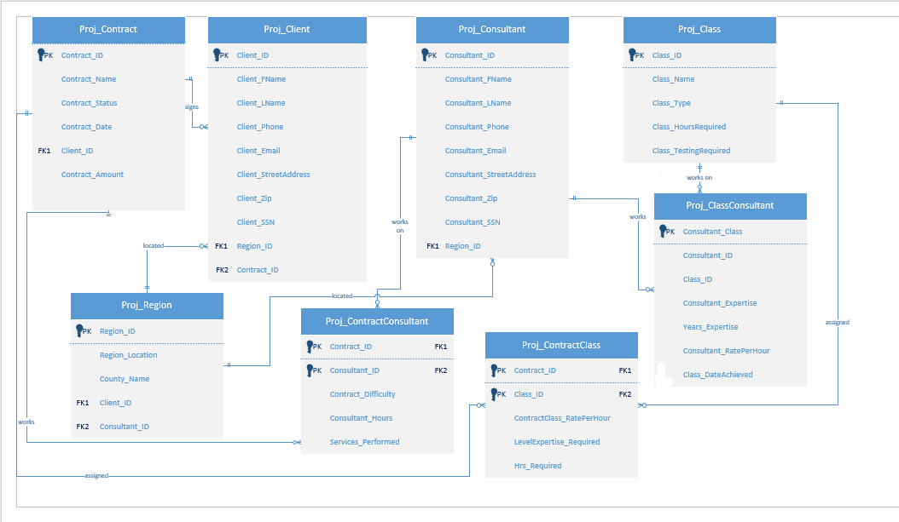
Relational Diagram
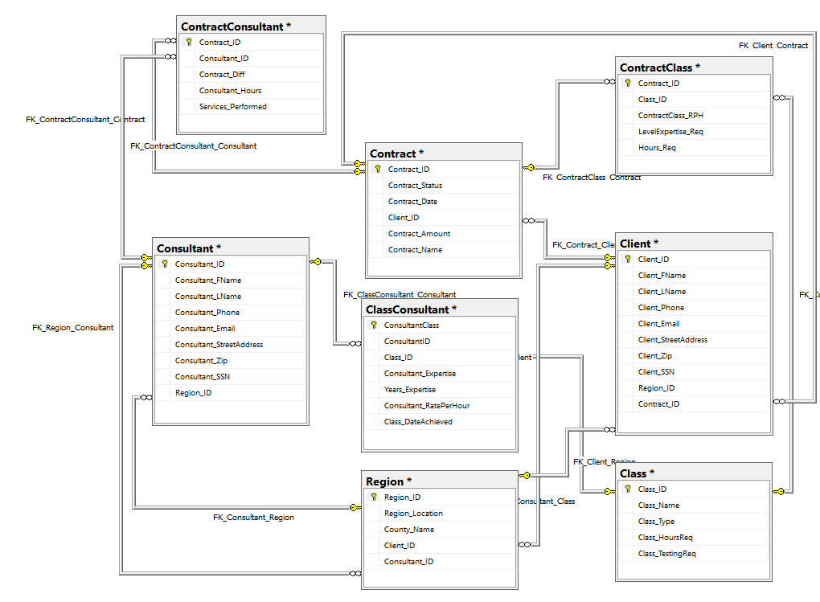

3NF Relational Schema:

Region (Region_ID, Region_Location, County_Name, Client_ID, Consultant_ID)

Contract (Contract_ID, Contract_Name, Contract_Status, Contract_Date, Client_ID, Contract_Amount)

Client (Client_ID, Client_FName, Client_LName, Client_Phone, Client_Email, Client_StreetAdress, Client_Zip, Client_SSN, Region_ID, Contract_ID)

ContractConsultant (Contract_ID, Consultant_ID, Contract_Difficulty, Consultant_Hours, Services_Performed)

Consultant (Consultant_ID, Consultant_FName, Consultant_LName, Consultant_Phone, Consultant_Email, Consultant_StreetAddress, Consultant_Zip, Consultant_SSN, Region_ID)

ContractClass (Contract_ID, Class_ID, ContractClass_RatePerHour, LevelExpertise_Required, Hrs_Required)

Class (Class_ID, Class_Name, Class_Type, Class_HoursRequired, Class_TestingRequired)

ClassConsultant (Consultant_Class, Consultant_ID, Class_ID, Years_Expertise, Consultant_Expertise, Consutlant_RatePerHours, Class_DateAchieved)
Queries

Query 1:

Description: Using these specific values from the Region, Client, and Consultant tables, we are identifying business relationships between the clients and consultants.

SELECT Region_Location, County_Name, Client_FName, Client_LName, Consultant_FName, Consultant_LName
FROM Region, Client, Consultant
WHERE Region.Client_ID = Client.Client_ID
AND Region.Consultant_ID = Consultant.Consultant_ID
ORDER BY Region_Location;

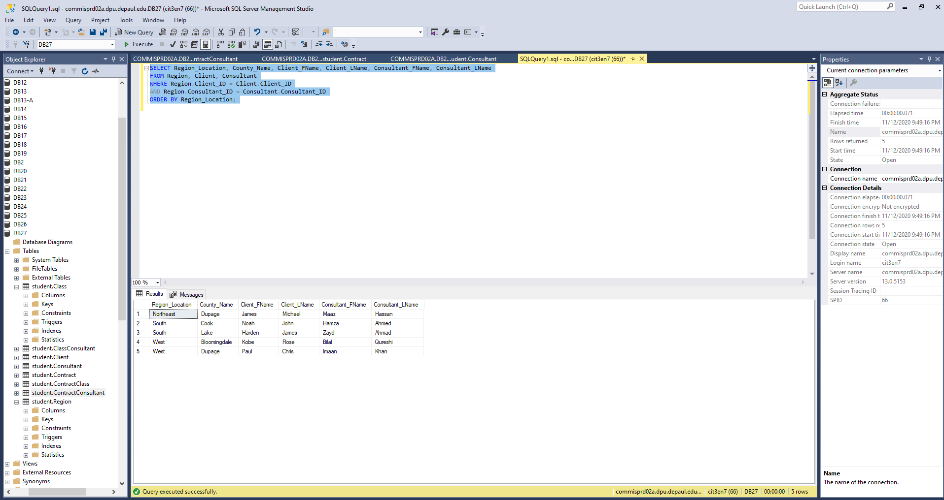

Query 2:

Description: Using values and relationships from the Contract, Consultant, and ContractConsultant tables, we find contracts that are still active.

SELECT Contract_Status, Contract_Name, Consultant_FName, Consultant_LName
FROM Contract, Consultant, ContractConsultant
WHERE Consultant.Consultant_ID=ContractConsultant.Consultant_ID
AND ContractConsultant.Contract_ID=Contract.Contract_ID
AND Contract_Status != 'Complete'
ORDER BY Contract_Status;

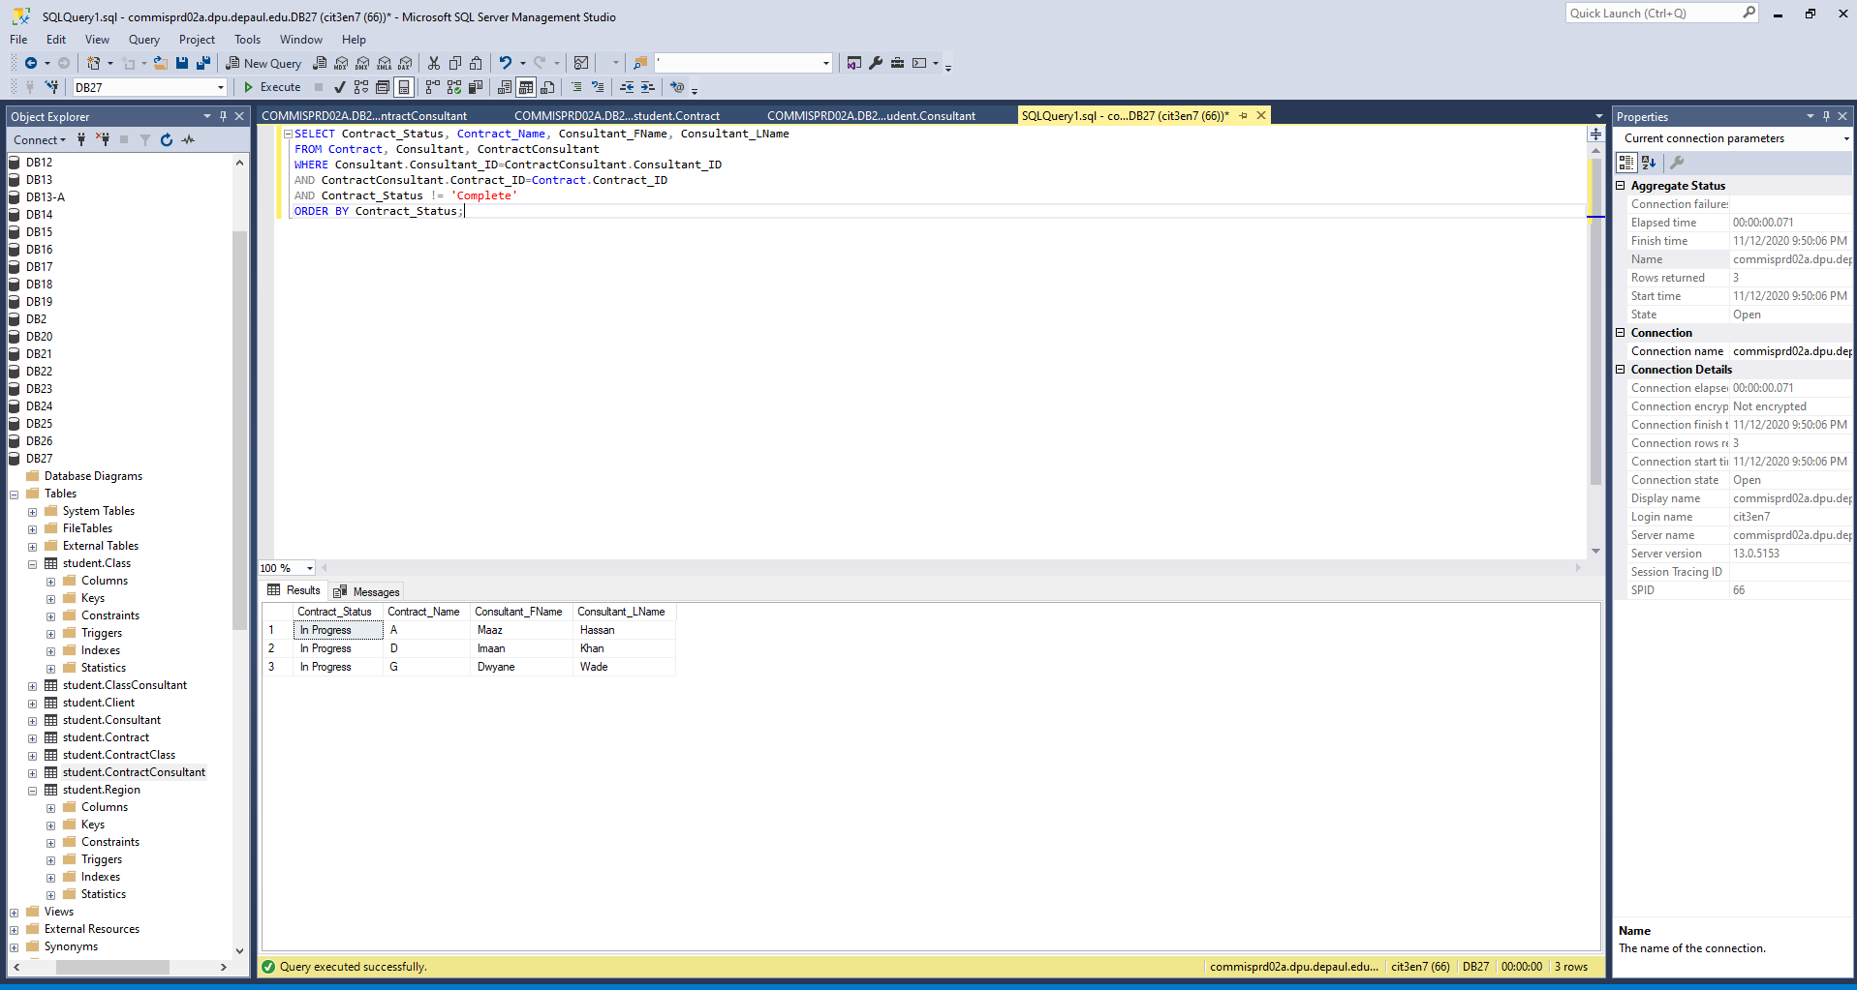

Query 3:

Description: This will identify which clients and consultants are located in the same geographic region.

SELECT Region_Location, County_Name, Client_FName, Client_LName, Consultant_FName, Consultant_LName
FROM Region, Client, Consultant
WHERE Consultant.Consultant_ID=Region.Consultant_ID
AND Client.Client_ID=Region.Client_ID
GROUP BY Client_FName, Client_LName, Consultant_FName, Consultant_LName, Region_Location, County_Name
ORDER BY Region_Location, County_Name;

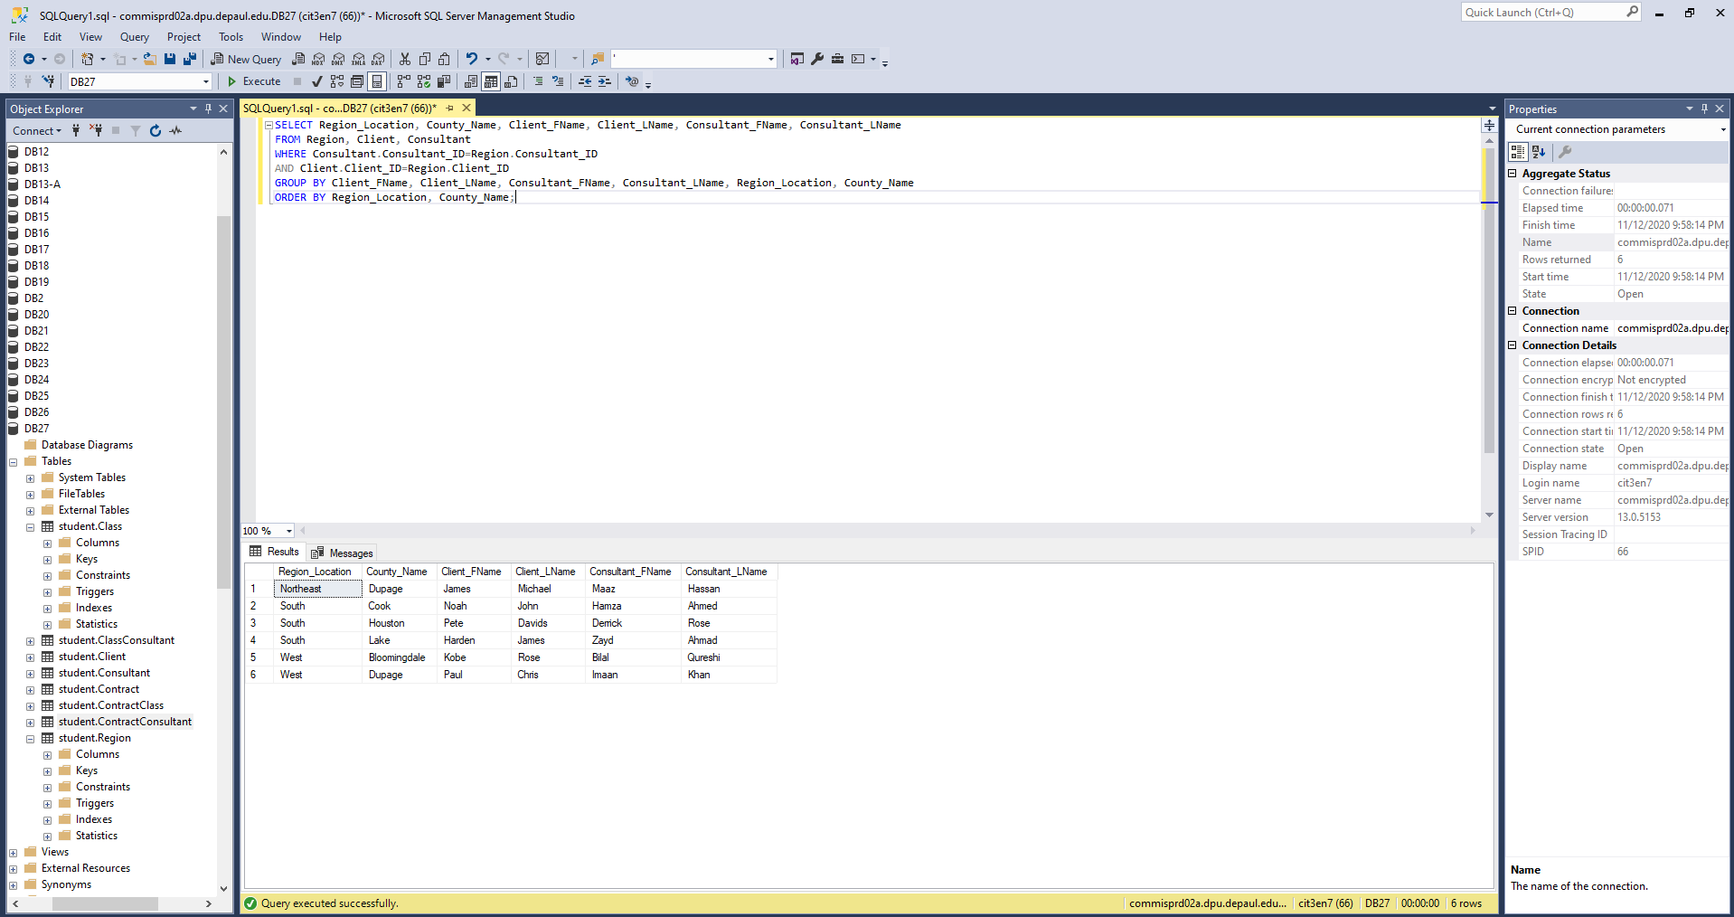

Query 4:

Description: This will filter out data from the Region table to identify consultants by region.

SELECT Region_Location, COUNT(Region.Region_Location) AS Number_Of_Consultants
FROM Region
GROUP BY Region_Location;

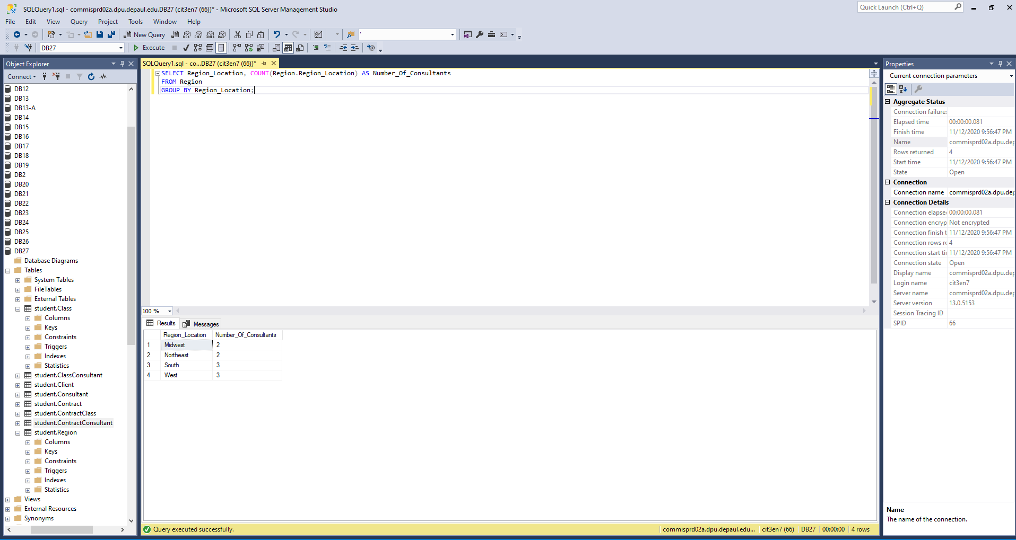
Query 5:

Description: This will identify all the relevant information of each consultant.

SELECT Consultant.Consultant_ID, Consultant_FName, Consultant_LName, Consultant_Phone, Consultant_StreetAddress, Consultant_Zip, Consultant_Email,
Region_Location, Consultant_Expertise, Years_Expertise, Consultant_RatePerHour, Contract_ID
FROM Consultant, Region, ContractConsultant, ClassConsultant
WHERE Region.Consultant_ID=Consultant.Consultant_ID
AND ClassConsultant.ConsultantID=Consultant.Consultant_ID
AND ContractConsultant.Consultant_ID=Consultant.Consultant_ID
ORDER BY Consultant_ID;

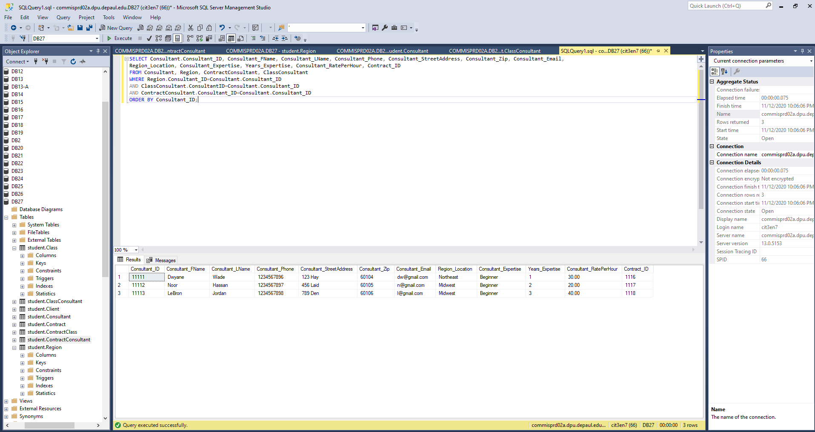

Query 6:

Description: This query displays all contracts that are currently in progress. This could help someone take out all complete contracts and only see those that are in progress.

SELECT Contract_Name, Contract_Status, Contract_Diff
FROM Contract, ContractConsultant
WHERE Contract.Contract_ID = ContractConsultant.Contract_ID and Contract_Status='In Progress';
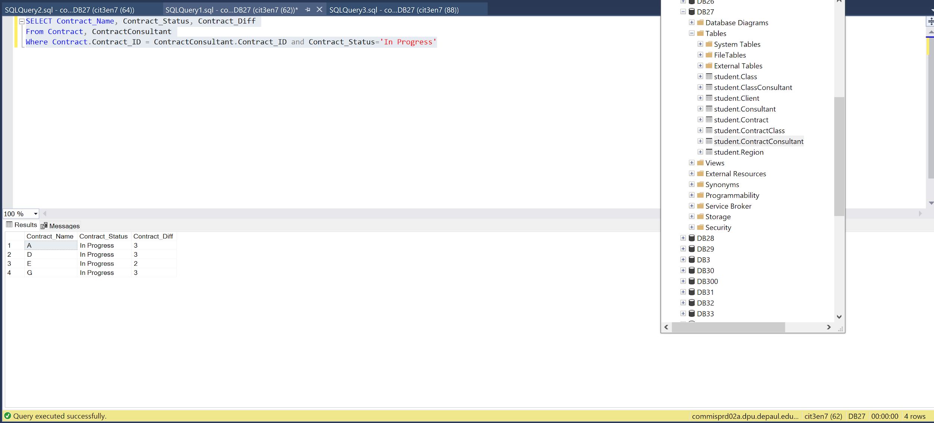

Query 7:

Description: This query displays contracts that are not complete and have a difficulty level of 3. This could be useful in seeing active contracts that are the most difficult.

SELECT Contract_Name, Contract_Status, Contract_Diff
FROM Contract, ContractConsultant
WHERE Contract.Contract_ID = ContractConsultant.Contract_ID
AND Contract_Diff='3'
AND Contract_Status !='Complete';

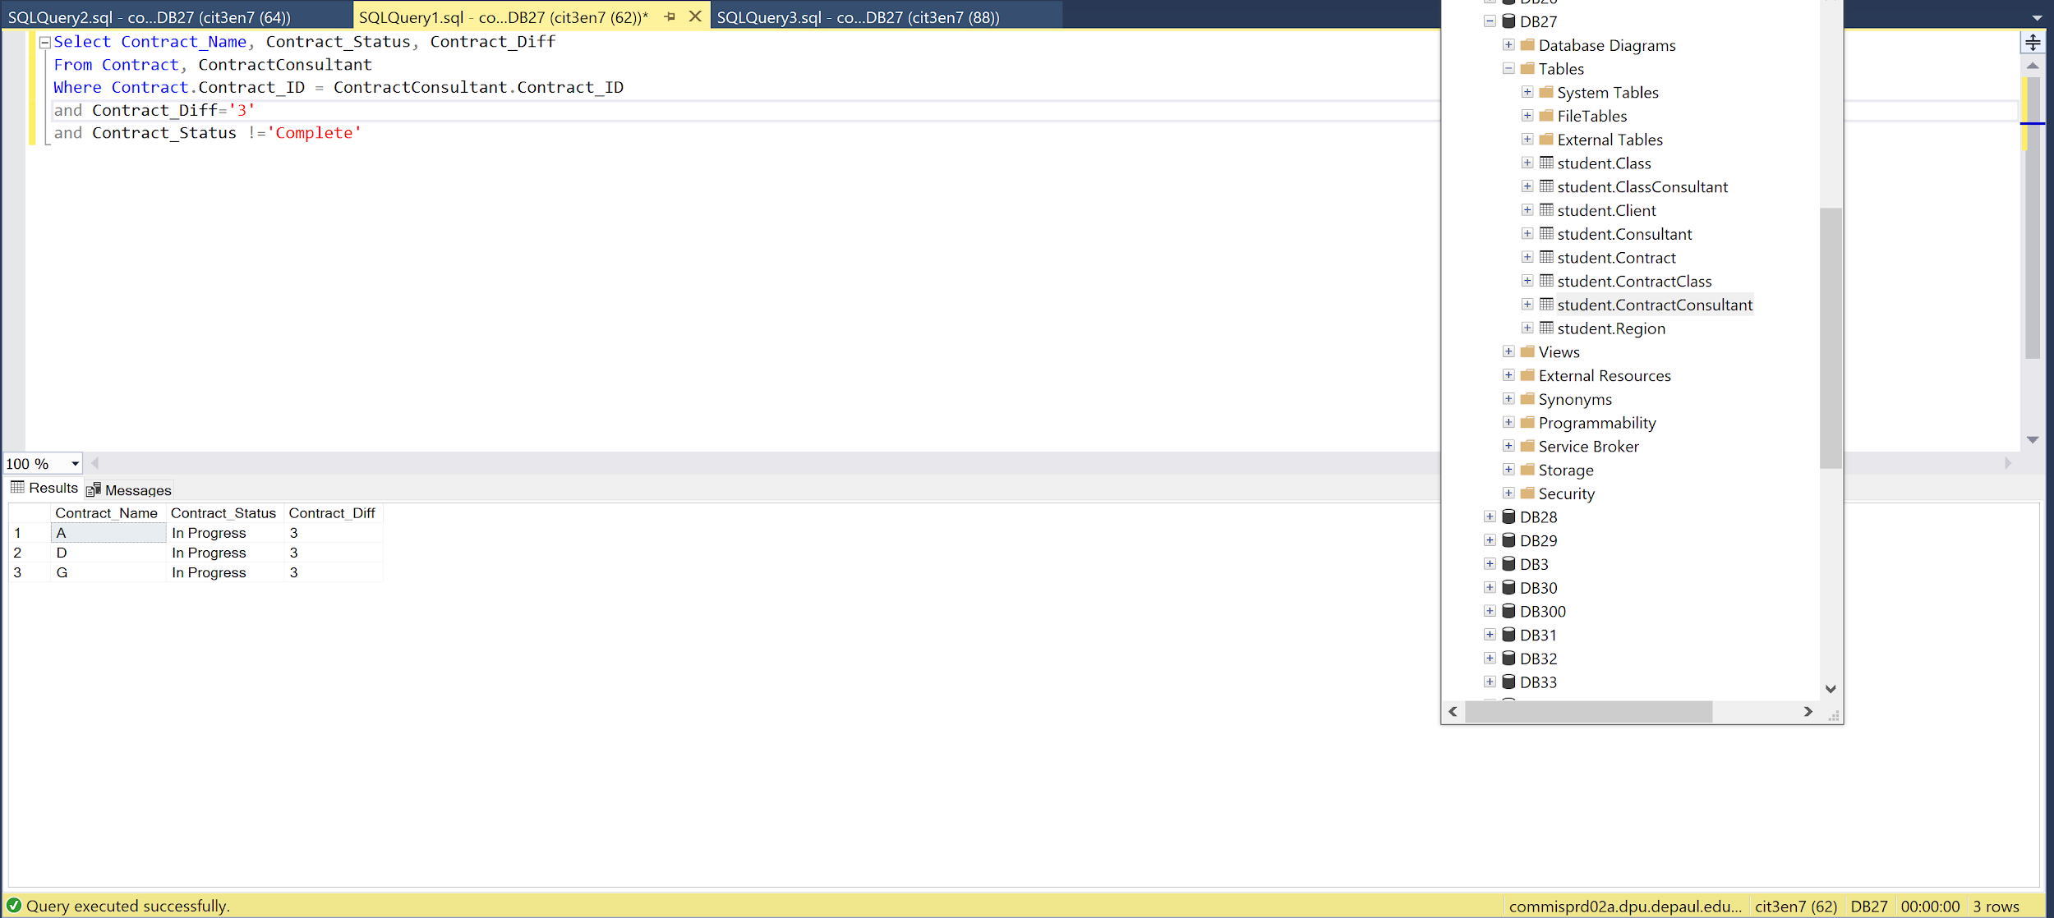

Query 8:

Description: This query shows contracts that are not complete and have a difficulty of 2. This is useful for finding past contracts that are of moderate difficulty.

SELECT Contract_Name, Contract_Status, Contract_Diff
FROM Contract, ContractConsultant
WHERE Contract.Contract_ID = ContractConsultant.Contract_ID
AND Contract_Diff='2'
AND Contract_Status!='Complete';

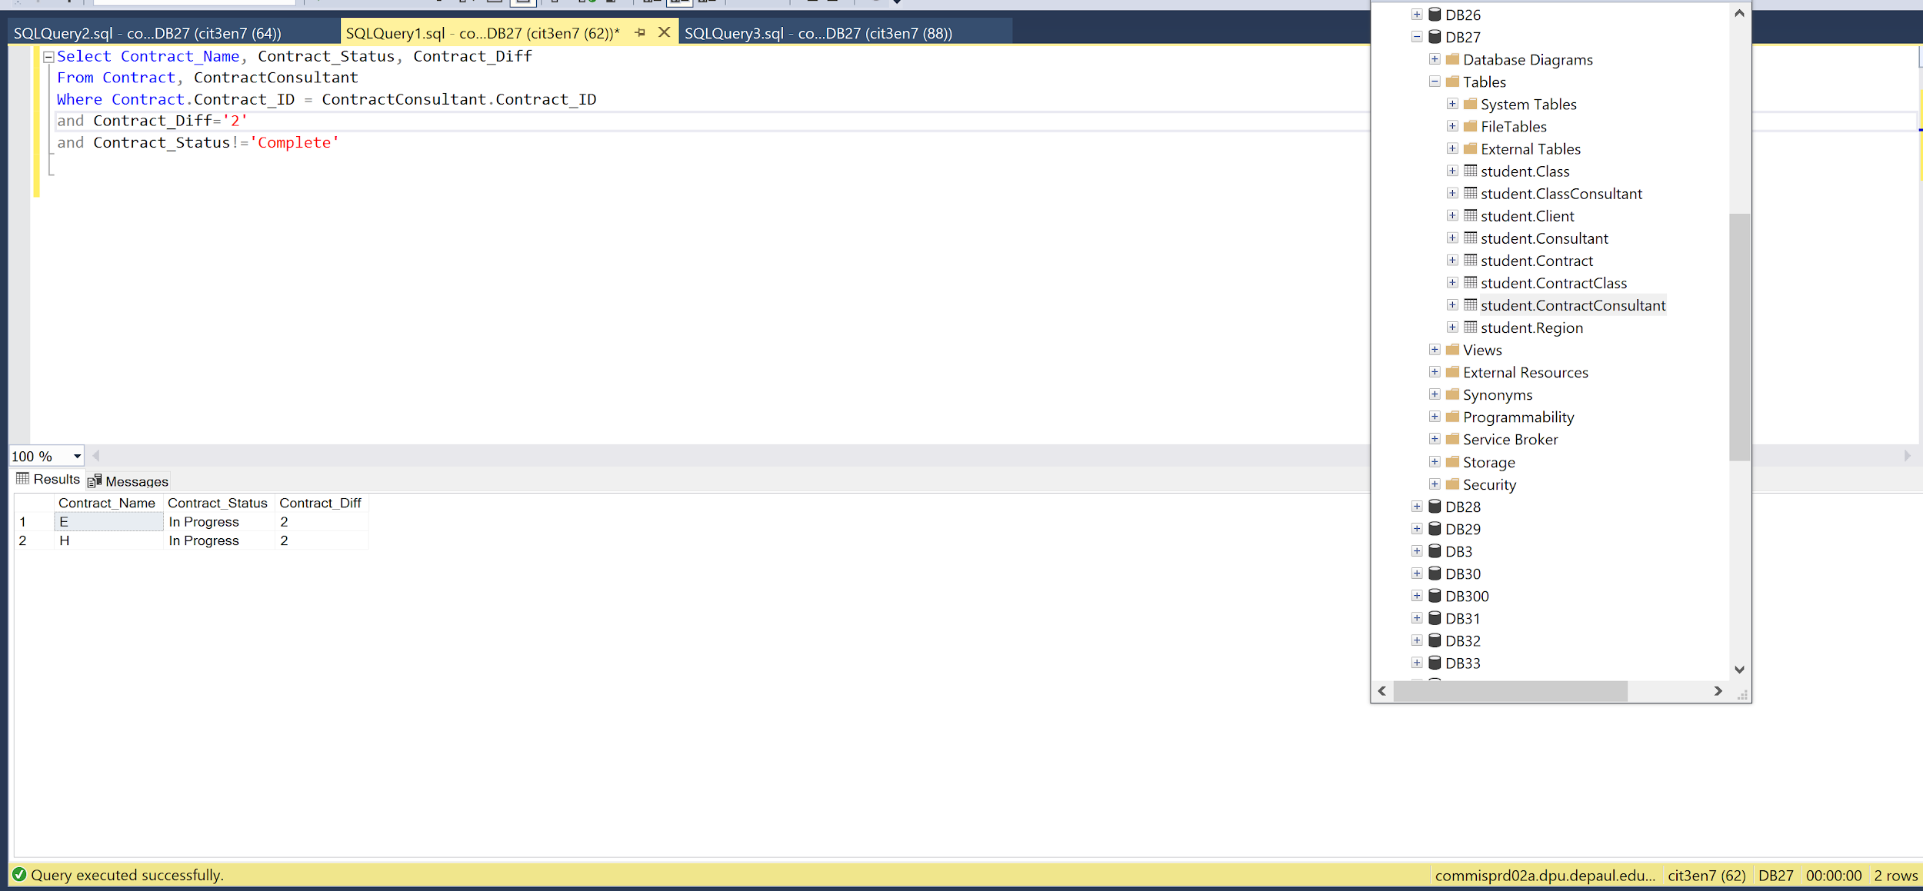

Query 9:

Description: This query shows contract information that includes the contract name, the status, the date, and the client's name and ID. This could be helpful when searching for the status of contracts and which clients they are for, as well as the contract date.

SELECT Contract.Contract_ID, Contract_Name, Contract_Status, Contract_Date,Client_FName, Client_LName, Client.Client_ID
FROM Contract, Client
WHERE Contract.Client_ID=Client.Client_ID
ORDER BY Contract_ID;

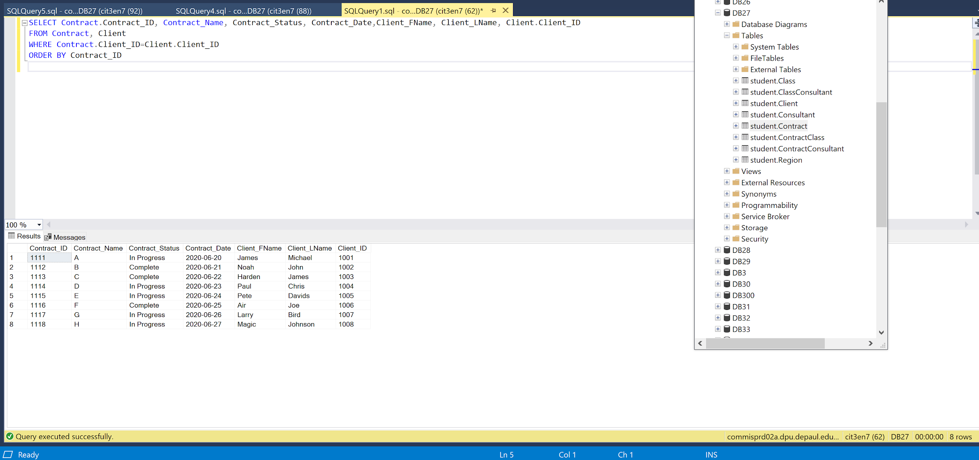

Query 10:

Description: This query displays client Information including the Client’s ID, Name, Phone, Address, and Region Location. This could be helpful for a business trying to search for a specific clients email address and phone number.

SELECT Client.Client_ID, Client_FName, Client_LName, Client_Phone, Client_StreetAddress, Client_Zip, Client_Email, Region_Location
From Client, Region
WHERE Region.Region_ID=Client.Region_ID
ORDER BY Client_ID;

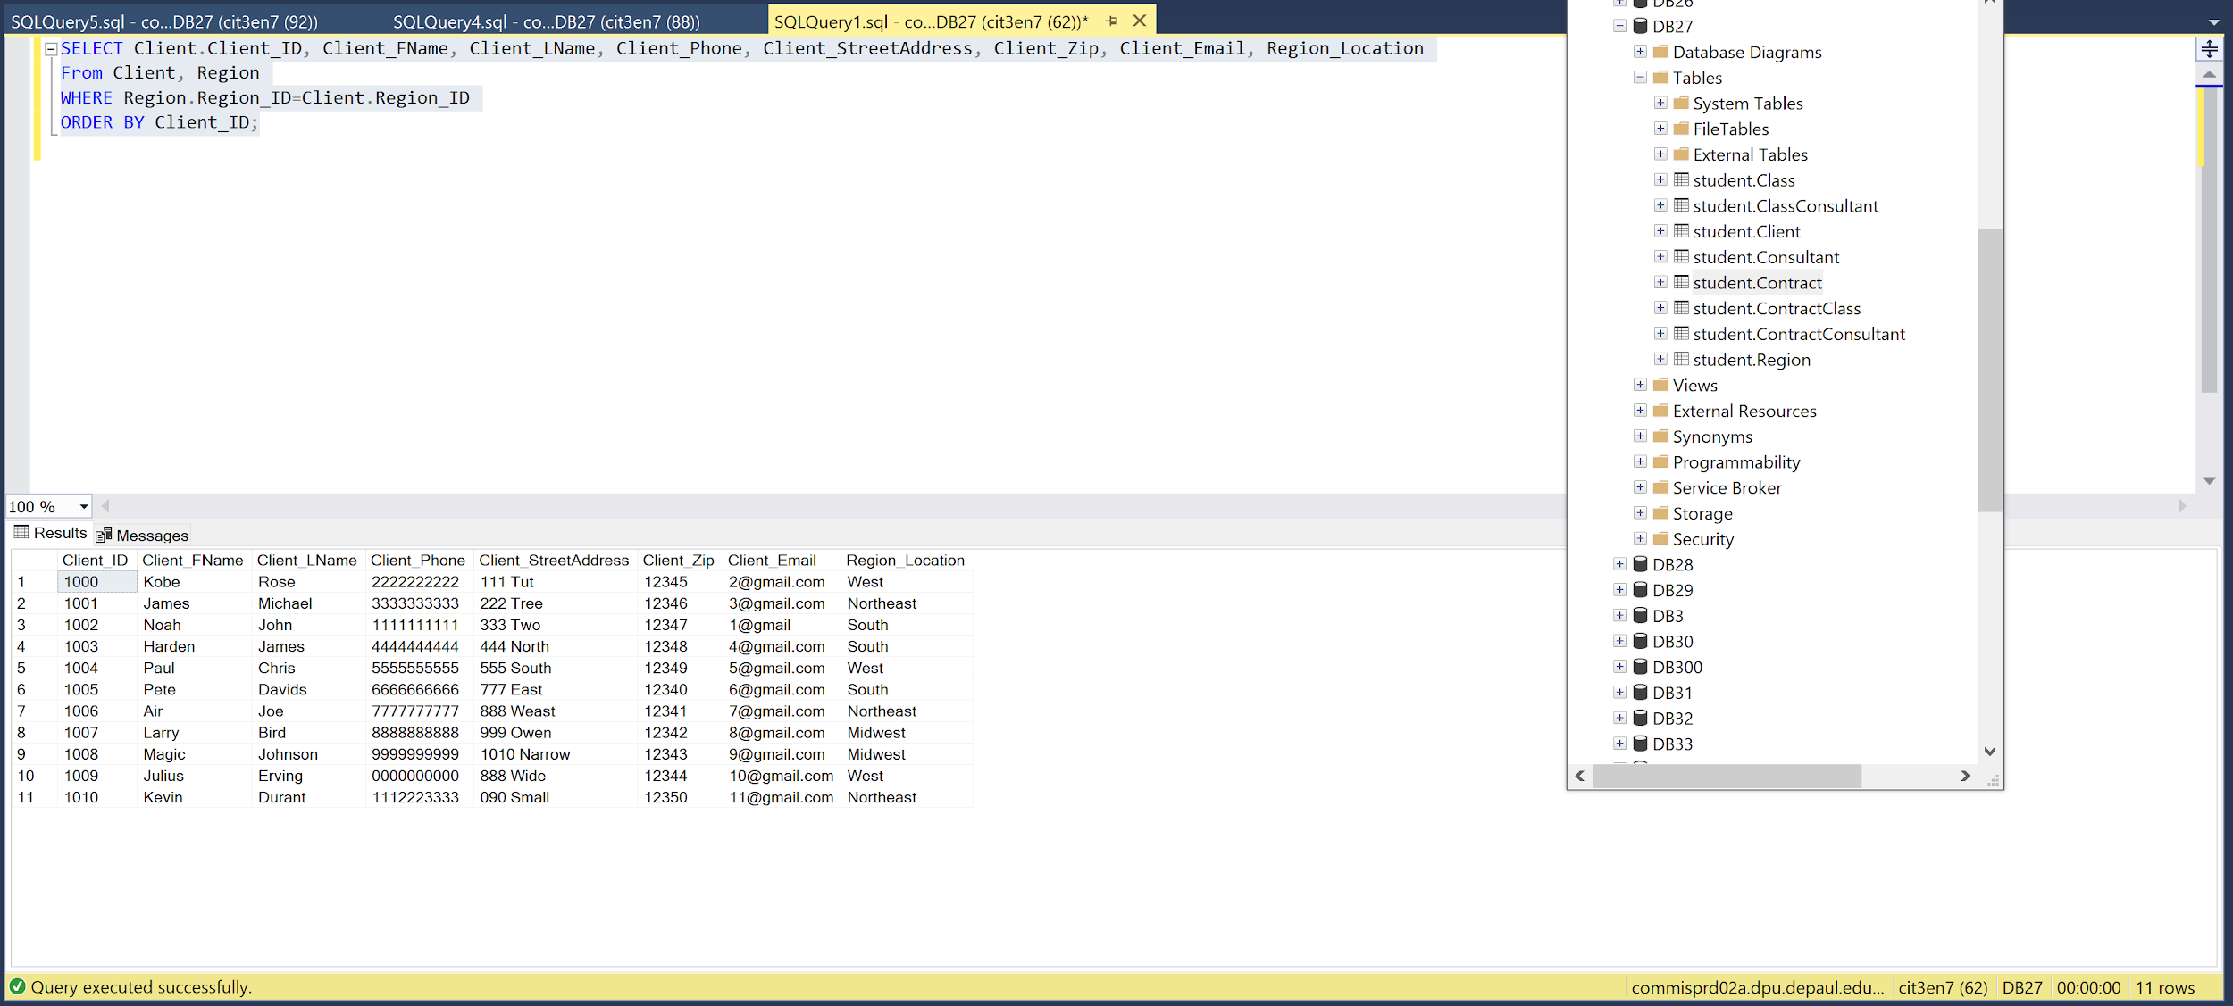

TABLES

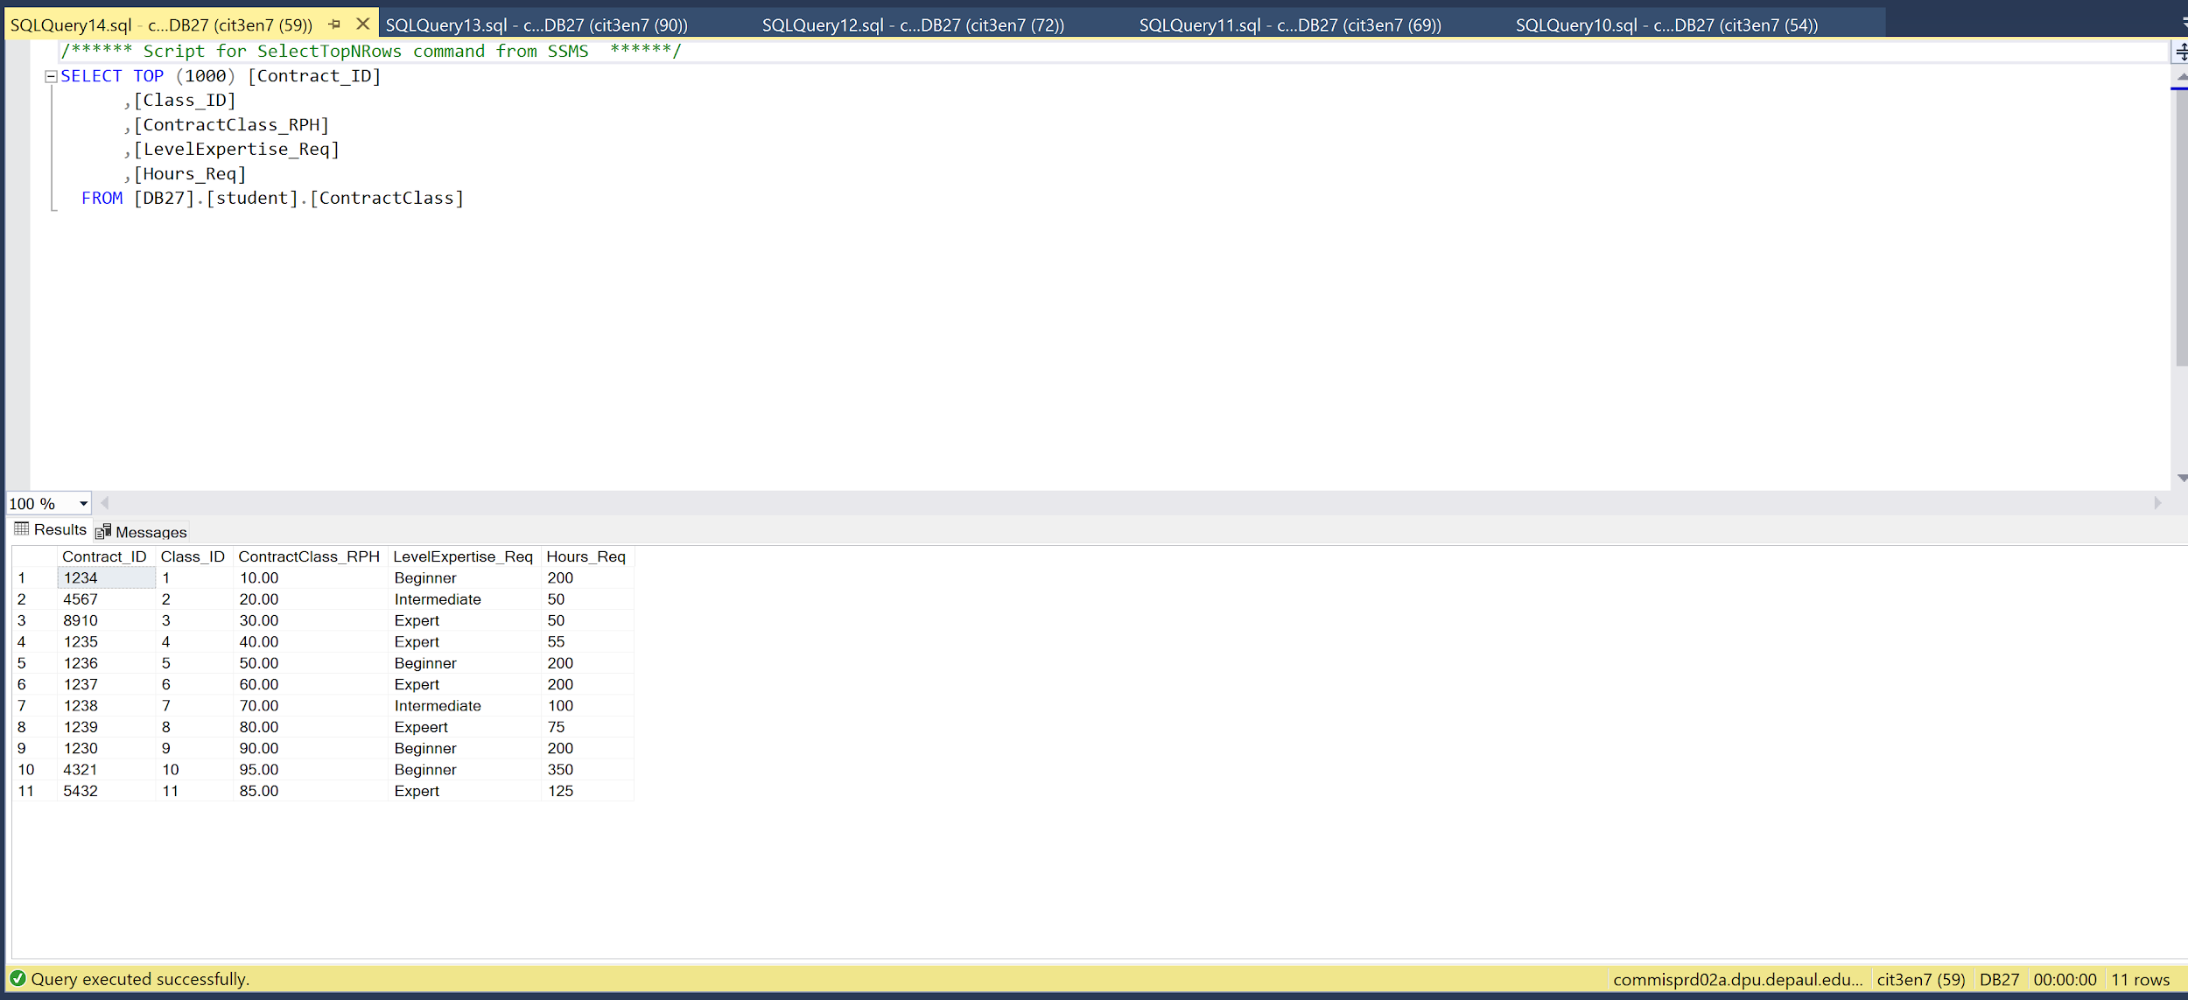
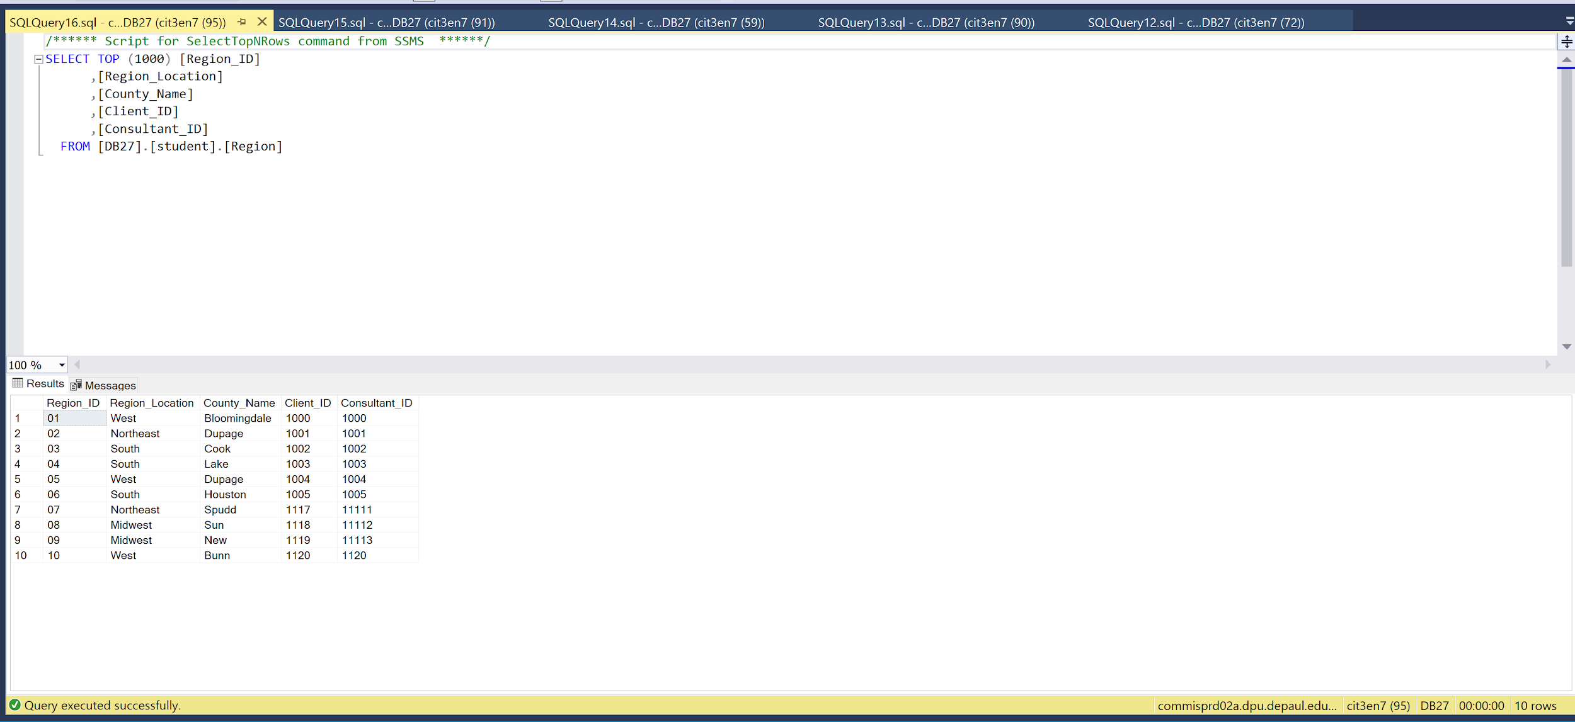
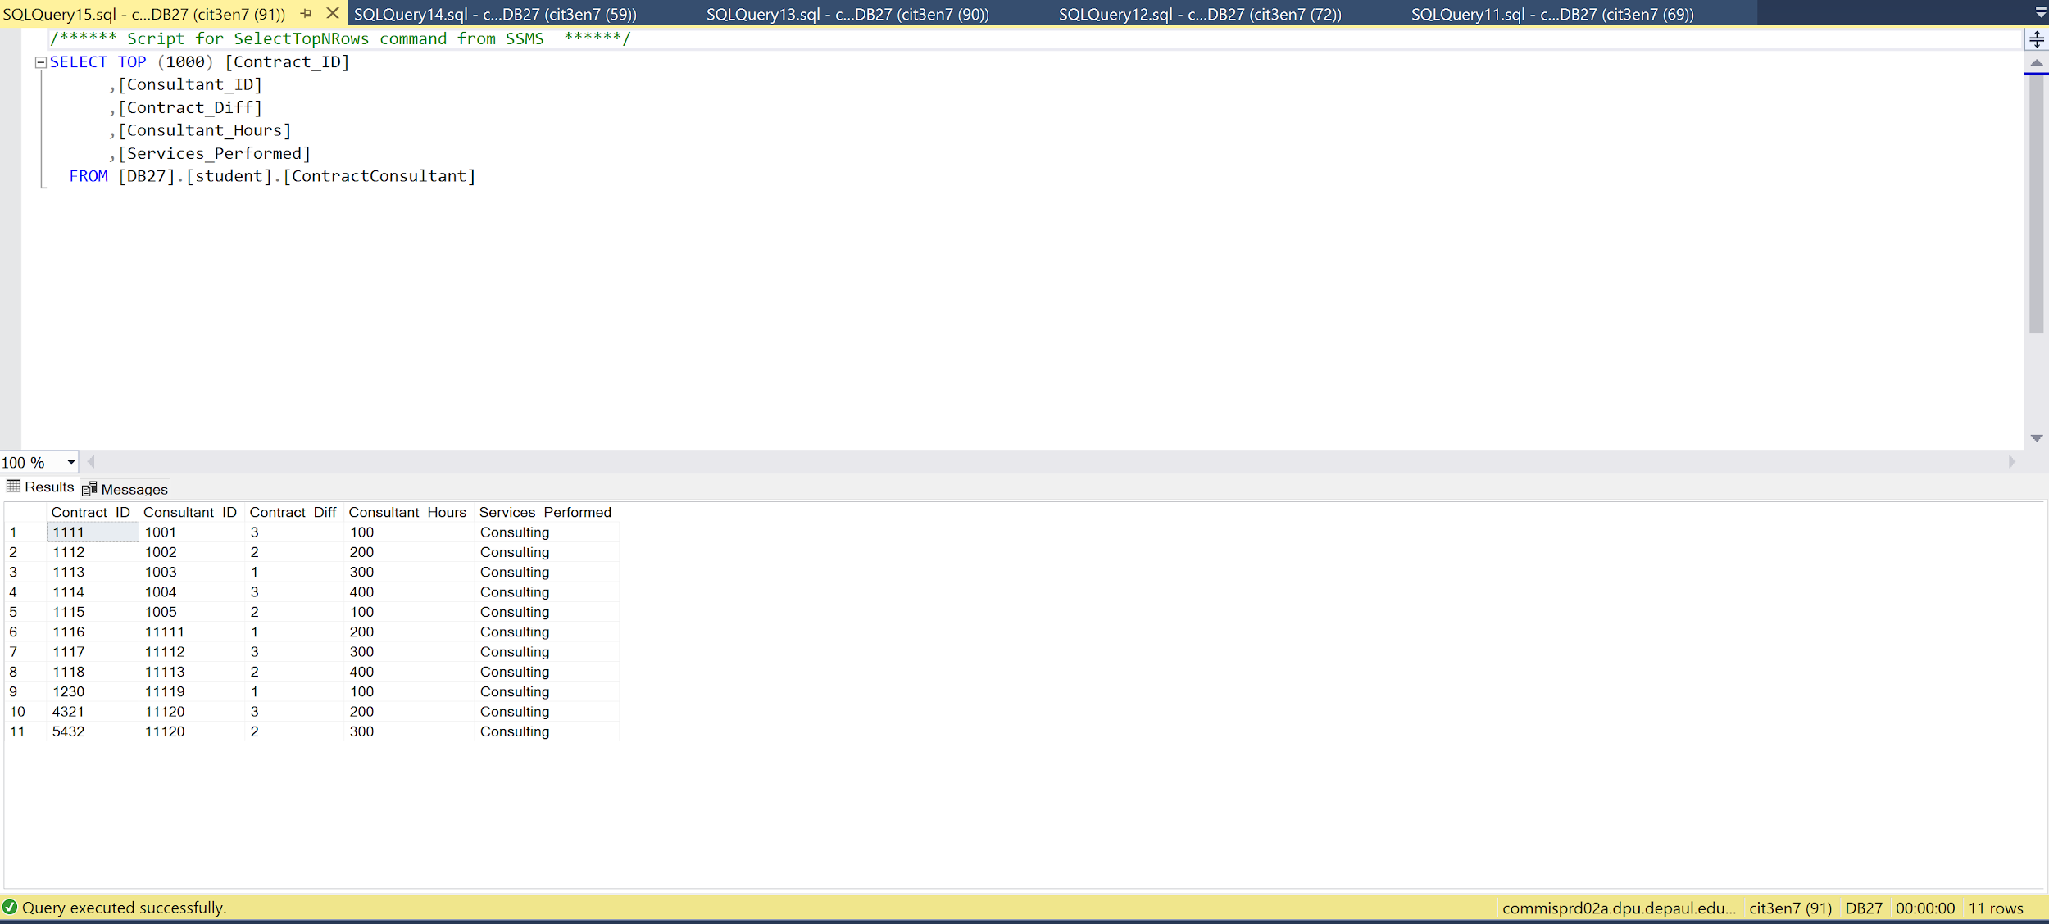
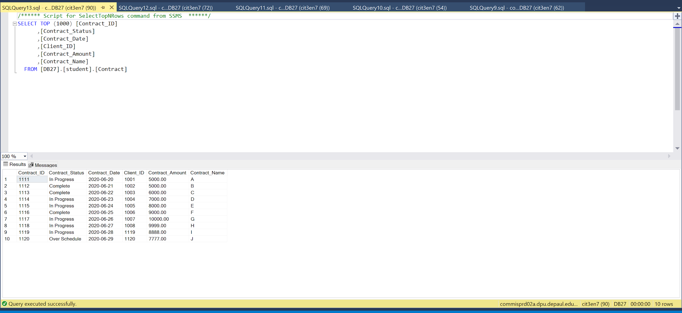

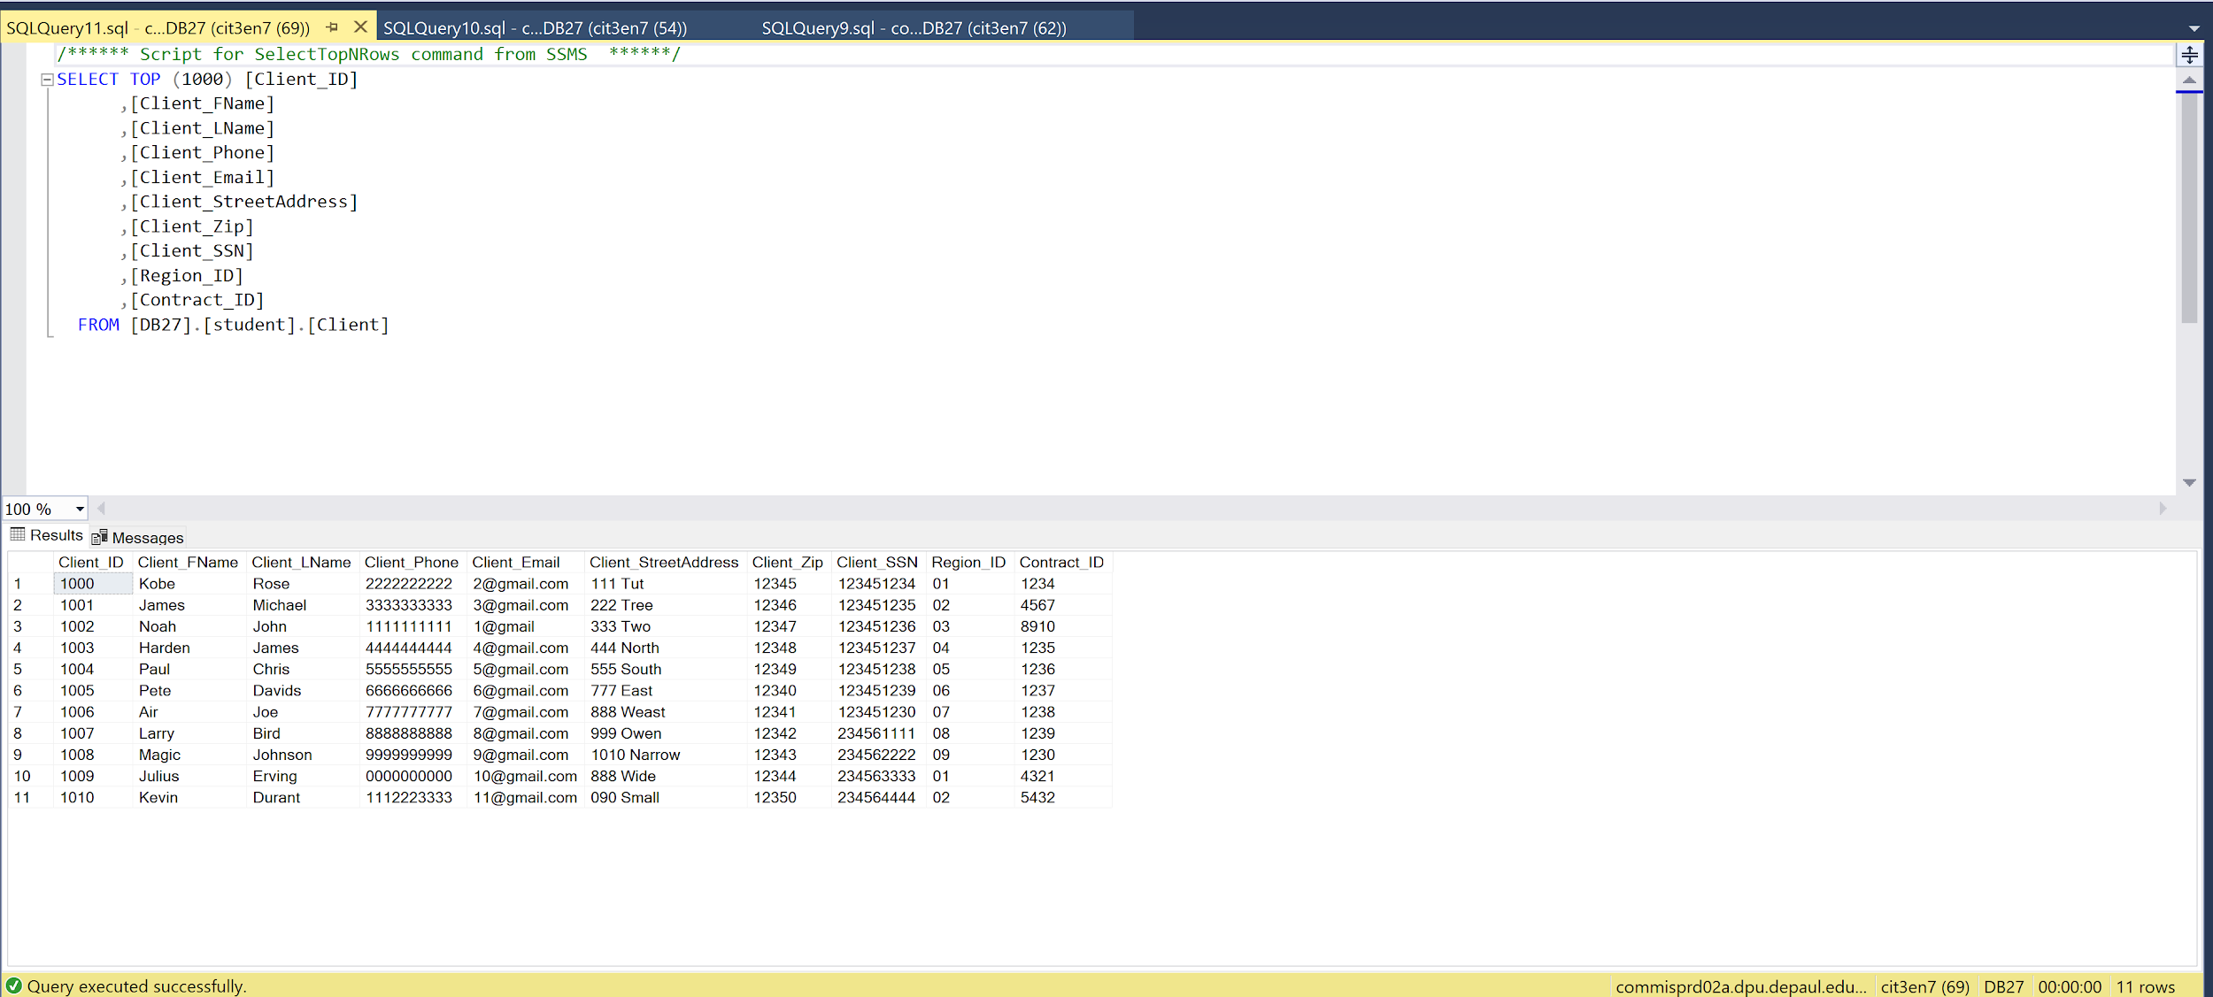
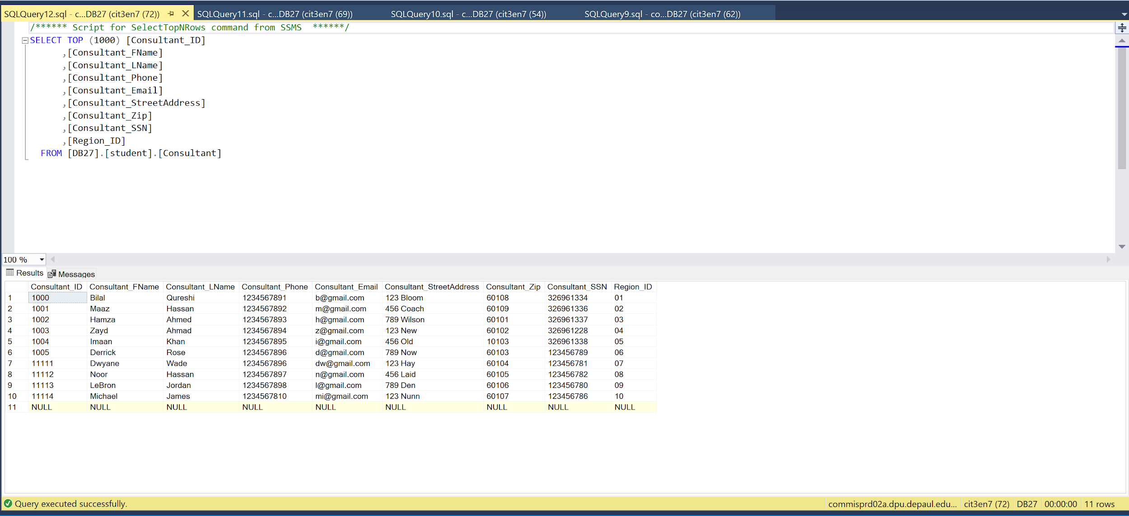

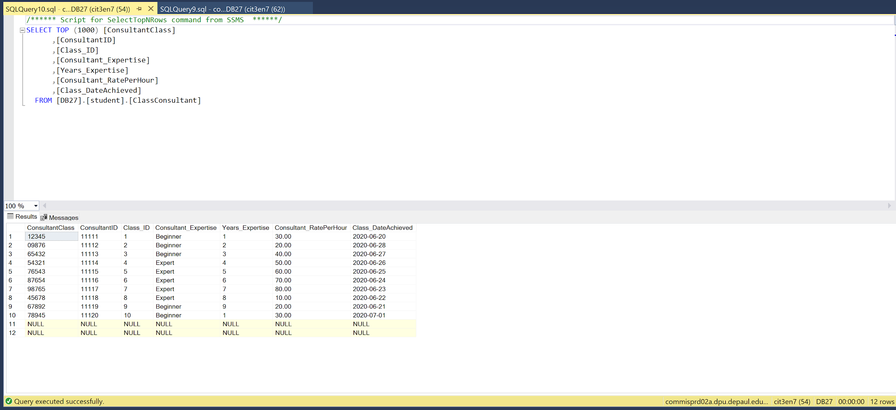

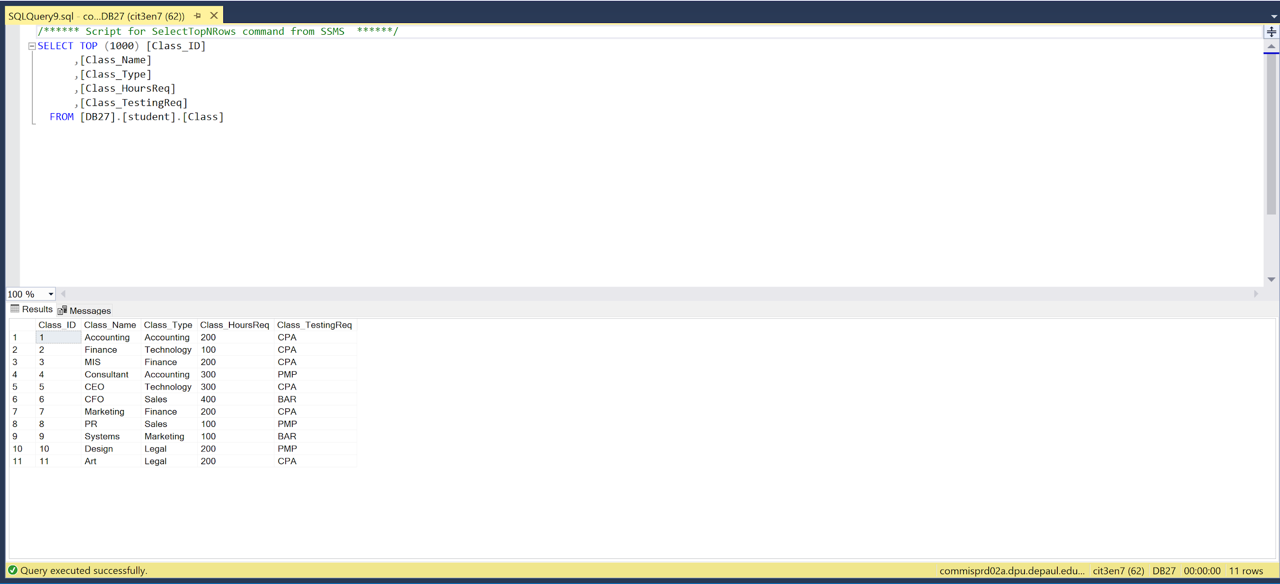

Table Designs

Region Table:

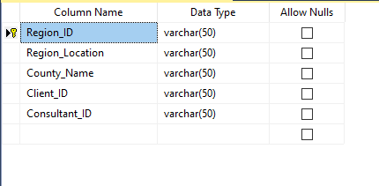

Contract Table:

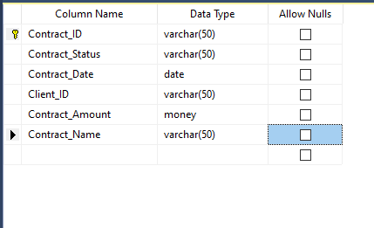

Consultant Table:

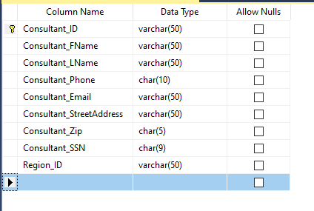

Client Table:
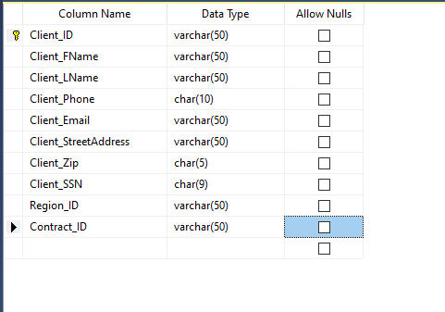

ClassTable:
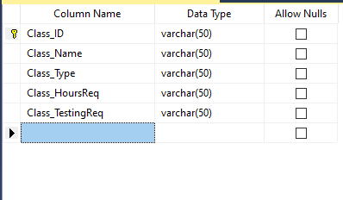

ClassConsultant Table:

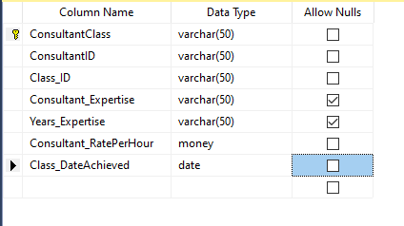

ContractConsultant:

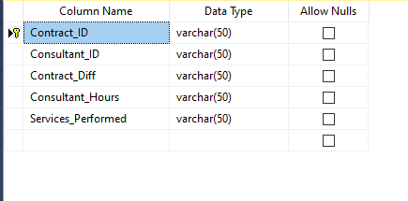

ContractClass:

